Herbert Hoover and the Great Depression

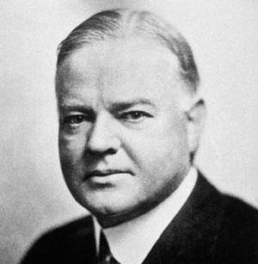
Herbert Hoover – President of the USA 1929 - 1932

Pinned hopes on Voluntarist approach
- Businesses were to pledge to maintain wages and employment
- Municipal and State Governments to create public works
- Set up National Credit Corporation to get larger banks to loan to smaller banks
- Taxes cut at homes
But, unemployment continued to rise. Some businesses broke pledge and cut wages
Public charities failed
Voluntarist approach failed
Public disillusionment with Hoover by late 1930 – Republicans lost 8 Senate seats and control of House of Representatives
1932 when National Election loomed Hoover set up The Reconstruction Finance Corporation. Congress provided $2 billion to make loans to large economic organisations – railroads & insurance companies. By July Hoover gave $2 billion toward Sate public works.

All failed to stop rapid rise in unemployment – millions suffering as a result
Measures taken by Hoover too little and too late
Also needed full support of:
- State Government to continue spending
- Farmers to cut production
- Employers to keep workers on payroll
- Banking system to be reformed with economic regulation
- Financiers tio invest money in provate enterprises
- Banks to return to offering credit
None occurred because most Americans had lost confidence in themselves, the economy and the Republican Government

Federal government had little experience in intervention of State or private enterprise – no national education system, no national Police force.
Laissez faire attitude had made the government reluctant to intervene on a By 1932 American people viewed Hoover as President who didn’t care – his ‘self-help’ attitude not useful in urban and industrial America.

Bitterness, resentment, violence grew.

Bonus Marchers
1932 late spring 20,000 Great War veterans marched in Washington demanding payments of Veterans’ Bonus’ to be paid in 1944 – much needed money for food and rent payments. Many evicted, homeless, no income Congess rejected it.
Anacosta Flats
Hoover ordered protestors to be confined to shanty town
28th July ordered eviction
1,000 armed soldiers drove veterans out of town and burned it to the ground – 2 veterans killed, thousands injured
Hoover cast in bad light – cruel and insensitive
Hoover became wildly unpopular

